- Open the QSV Calibration selection Table spreadsheet and select the correct tab for the Engine Serial Number range.

- Identify the correct FR option. The FR option is stamped on the engine data plate or can be identified through QSOL. Note the data in that row. For this example, FR7131 has been selected.

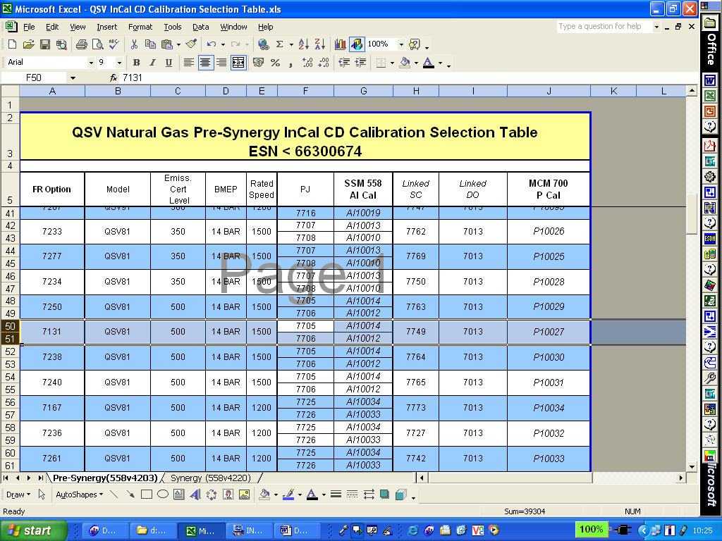

The MCM 700 P Cal column identifies the correct MCM calibration for this rating, P10027, which can be downloaded to the ECM with INSITE.

.

- To Identify compatible SSM calibrations, alternate click on the desired ECM code, select ‘View compatible ECM\FCM Calibrations’ and select the part number ‘3607754’

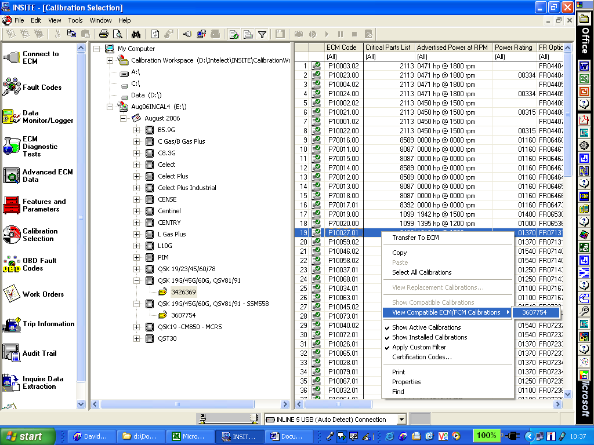

You are now presented with 4 calibrations for the SSM module.

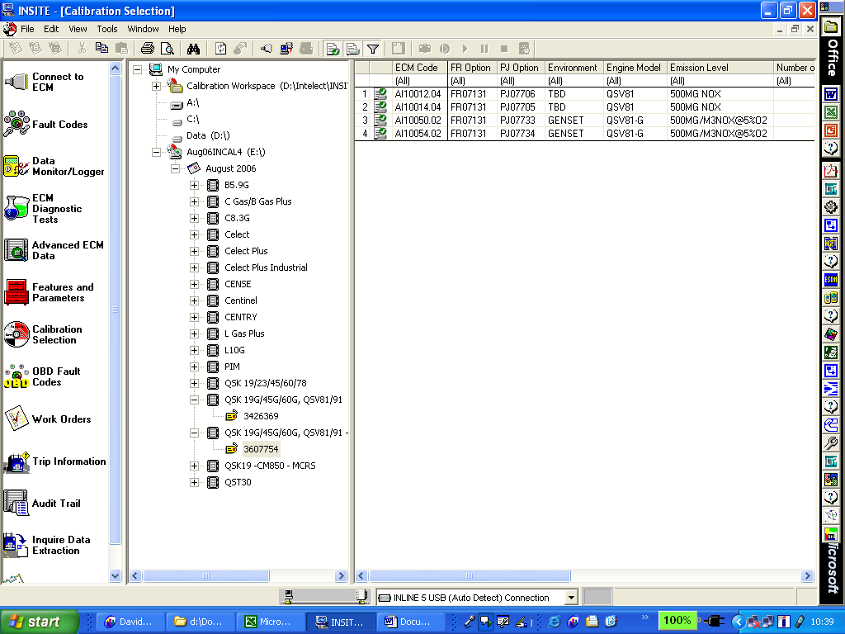

- Refer to the QSV Calibration Selection Table spreadsheet, SSM 558 AI Cal column to identify the correct A & B bank calibrations for your Engine.

In this example, AI10014 & AI10012 are required.

- Scroll to the right to the Comment column to identify which bank the calibration is structured for.

- The calibration can then be downloaded to the ECM with INSITE.

